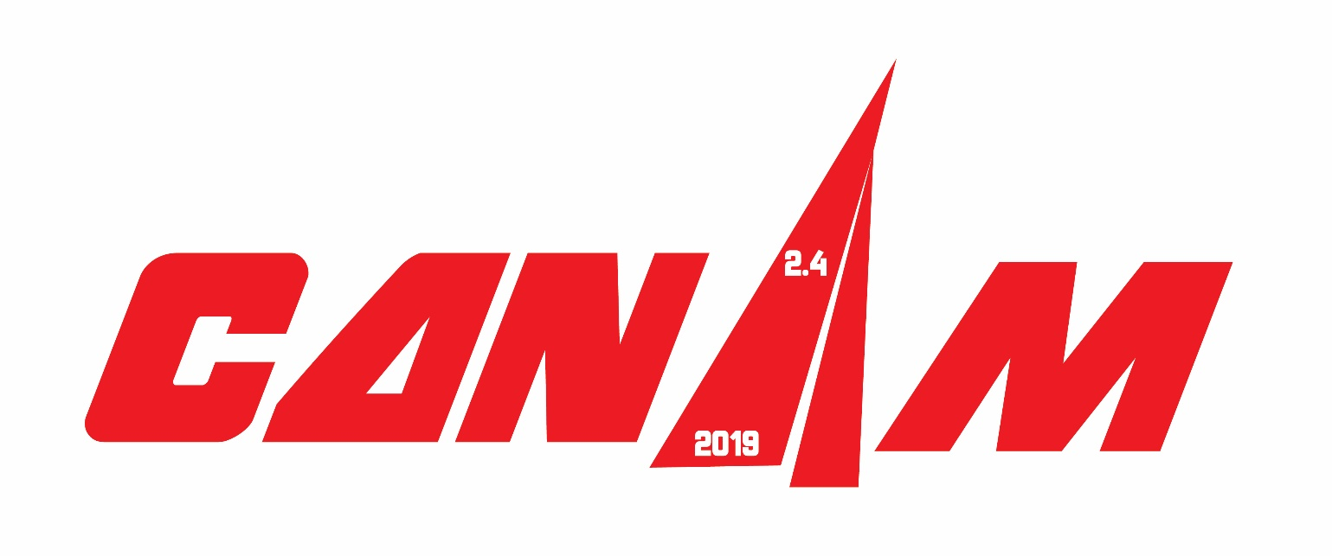
Millar Wins 2019 Edge Sailing Midwinters
Event Three of the 2019 CanAm Championship Series

Port Charlotte, Fla. (January 29, 2019) – Sixteen competitors took to the waters of Charlotte Harbor over the weekend of January 25-27 for the 2019 Edge Sailing Midwinters -- event three in the five-event 2.4 Meter Can Am Championship series. Unlike the previous two events, which each saw four competitors rack up first-place finishes in the 20-strong fleet, the leaderboard for the Edge Sailing Midwinters was dominated by two veteran racers: 2015 2.4mR North American Champion Bruce Millar, of Victoria, British Columbia, and 2018 2.4mR North American Champion Dee Smith of Annapolis, Maryland.
On the first day of racing, featuring overcast skies, intermittent rain, and eight to 10 knots of breeze with gusts to 14 from the north-northeast, four races were run. And while the Race Committee was obliged to make course changes due to shifts in the breeze and pressure changes in three races, the ebb tide and flat water were not adverse factors for the competitors.
In the first race, Millar picked up a 17-point penalty after confusion at a mark rounding resulted in his being disqualified from that race. However, he rebounded quickly by winning the subsequent two races and placing second in the final race of the day. Smith, meanwhile, finished 1-2-2-1 in those races, to finish the day at the top of the leaderboard with six points to Millar’s 21.
On the second day of racing, the forecast was for gusts to 35 knots, which, fortunately, never materialized. However, the squall that came through during race one, bringing sometimes heavy, intermittent rain, turned into a consistent torrent during race two that was not enhanced by the 55-degree temperatures. Only the two races were sailed, with Smith winning the first, and Millar winning the second.
Notably, Smith did not sail the final race of the regatta, mistakenly thinking he had secured the win. “Of course, I didn’t do my math very well,” said Smith. “Racing with Bruce was very close the whole regatta. I won the first one, he won the next two, I won the next two. The last race that I sailed, I was over the line early, had to go back and grind my way through the fleet. I was one boat length behind Bruce at the weather mark…stayed the same on the run, and we took different marks at the gate. When we crossed the next time, I had the lead and did not look back. I thought I won the regatta.”
On the last leg of the final race, after a short tacking duel with Tony Pocklington, of Fort Myers, Fla., Millar prevailed to cross the finish line first to win the regatta. Tied on seven points with Millar, Smith lost the tie-breaker which is decided by the scores in the last race sailed.
Pocklington’s scoreline for the regatta, 4-6-[7]-4-4-2, placed him third overall with 20 points. The close competition included a photo finish, also in that last race, for Tim Ripley, of Randolph, N.J., and Charlie Rosenfield of Woodstock, Conn., who crossed the line, respectively, third and fourth. Rosenfield took fourth overall in the standings with 22 points, while Peter Eagar of Toronto, Canada, took fifth with 24 points.
“I personally don’t have a preferred condition,” said Millar after securing the win of the 2019 Edge Sailing Midwinters. “I don’t worry about whether its heavy or light. I like to be at the top [of the results], but I don’t want that to be my focus and I figure the result will come. Dee is a fantastic sailor. We all know he is the sailor that starts the best and he has years and years of experience. It’s something you have to contend with. I have very good boat speed…I can match him, so it puts me together with him a lot of the time if I’m doing my job right. It just takes one mistake and that is the difference between one position. It pushes you hard and makes you think all the time and that’s why I enjoy the sport, because it’s a thinking game.”
Racing for the third edition of the 2.4 Meter Can Am Championship series will resume February 22-24 with CanAm #4. The nine-race 2019 CanAm Championship Finale, from March 29-31, will see a regatta winner as well as the determination of the series champion from the results of all five regattas after his or her worst event is dropped from the scoring. For competitors who do not race in all five events, the scoring will count all events sailed (i.e. they will not drop their worst result). Leading the current standings for the 2019 CanAm Championship Series is Dee Smith with five points. He is followed by Bruce Millar with eight points. Tony Pocklington has moved into third with 17 points, just one point ahead of Allan Leibel. Peter Eagar rounds out the top-five with 21 points.
Details of the regatta schedules, social events, hotels and more may be found in the Notice of Race, available here. Full results for the 2019 Edge Midwinters may be found at http://www.regattanetwork.com/event/17798#_newsroom
Links to the results for the first two events in the 2019 Can Am Championship Series are: 2018 2.4mR North American Championship http://www.regattanetwork.com/event/17779#_newsroom ; and 2018 2.4mR U.S. Nationals http://www.regattanetwork.com/event/17797#_newsroom
About the 2.4mR: The 2.4mR originated in 1983 in Sweden and attained confirmation as an international class less than 10 years later. Class racing puts the emphasis on the tactical – not physical – skills of the sailor as the single-handed boats are equal under the strict rules that govern the class. With a length of 13’ 8” and the advantage of being easily transported and stored, this sleek keelboat has gained favor with a wide range of able-bodied sailors and sailors with disabilities (there are 1200 boats worldwide, with roughly 200 in North America). For more information on the class, please visit http://www.canada24mr.com/ or www.us24meter.org/

